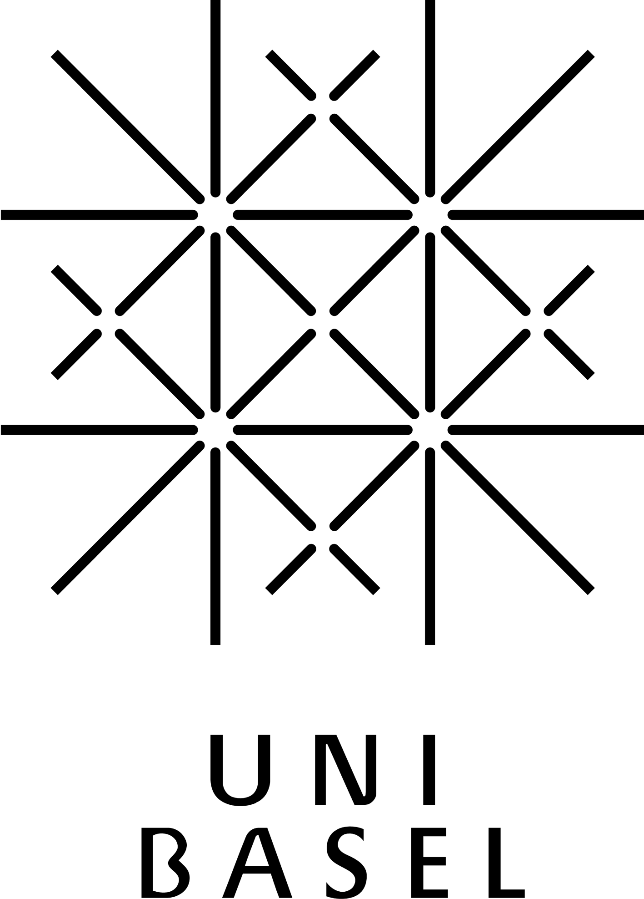

Call for Applications

Interconnected – Actors, Objects and Ideas on the Move

3rd GRAINES Summer School, St Andrews, 7-10 June 2015

GRAINES network and the Institute for Transnational & Spatial History, St Andrews
in collaboration with the Institute for Intellectual History, St Andrews & Global Cities (AHRC Project)

Over the past years, networks, along with Actor-Network-Theory, have attracted scholars’ attention. While networks are not new as a topic, they have gained attention in particular in the field of global and transnational history. As part of global and transnational research perspectives, as well as in urban or intellectual history, in the history of science or in economic history networks serve multiple purposes. All these fields share an interest in processes of exchange, in connections and flows of people, goods and ideas that can be tracked and analysed through networks.
In these and related fields networks can be:
• objects of research
• outcome of research
• a heuristic device and tool in order to generate research agendas.

Networks may also serve as a way of seeing spatial relations and dynamics beyond (or in addition) to more conventional geographical and territorial frameworks, e.g. nations, empires, regions, cities. The increasing interest in the study of networks coincides with a rapidly changing research environment and the rise of Digital Humanities. A variety of software and computing tools are available to visualise data and networks. This again poses questions on how to treat data, how to narrate and how to collaborate across and between disciplinary boundaries.

In the vein of previous GRAINES summer schools we invite applications from within and beyond the GRAINES network. While GRAINES shares a strong historical orientation with a focus on European history from the late medieval period to the present, we welcome applications from neighboring disciplines like Art History or Literature as well as the sciences (geoscience and computer science).

The purpose of the summer school is to bring together scholars and postgraduate students working on or with the concept of networks in projects related to transnational, global, urban and intellectual history. The summer school will seeks to be a forum for sharing and collaborating, for knowledge production rather than consumption. In conjunction with more traditional elements such as reading groups, paper presentations, we adopt different elements of collaboration inspired by the model of “unconferences” (a model we successfully used for the “Mapping and Visualising Transnational (Hi)Stories” workshop in June 2014) as well as “Pair programming” in the Humanities.

See: http://transnationalhistory.net/mvth/
http://chronicle.com/blogs/profhacker/pair-programming-could-something-similar-work-in-the-humanities/32089

Please send your proposal as a single word or PDF document (abstract of a project / proposal of max 250 words; brief biographical sketch of max 150 words including the motivation to participate and what you are willing to contribute & share during the summer school, e.g. contribute to reading group, writing session, workshop introducing a tool or software) to
Giada Pizzoni, mail: graines.interconnected@gmail.com

Fees: 130 GBP – includes: 4 nights student hall accommodation with B&B, dinner and catering during summer school. Travel expenses are not included.
Fees: 50 GBP – participation without accommodation.

Submission Date: 9 March 2015

For further information on Interconnected and GRAINES see
http://transnationalhistory.net/interconnected/
http://grainesnetwork.com/

